NETWORK INTELLIGENCE GATHERING ACTIVITY

Ping Sweep on 192.168.10.0/24
1. Command Used in Kali Linux
Open the terminal and run:
nmap -sn 192.168.10.0/24
This command checks every IP address in the network and shows only the devices that are active (online).

2. Active Hosts Fund (Example)
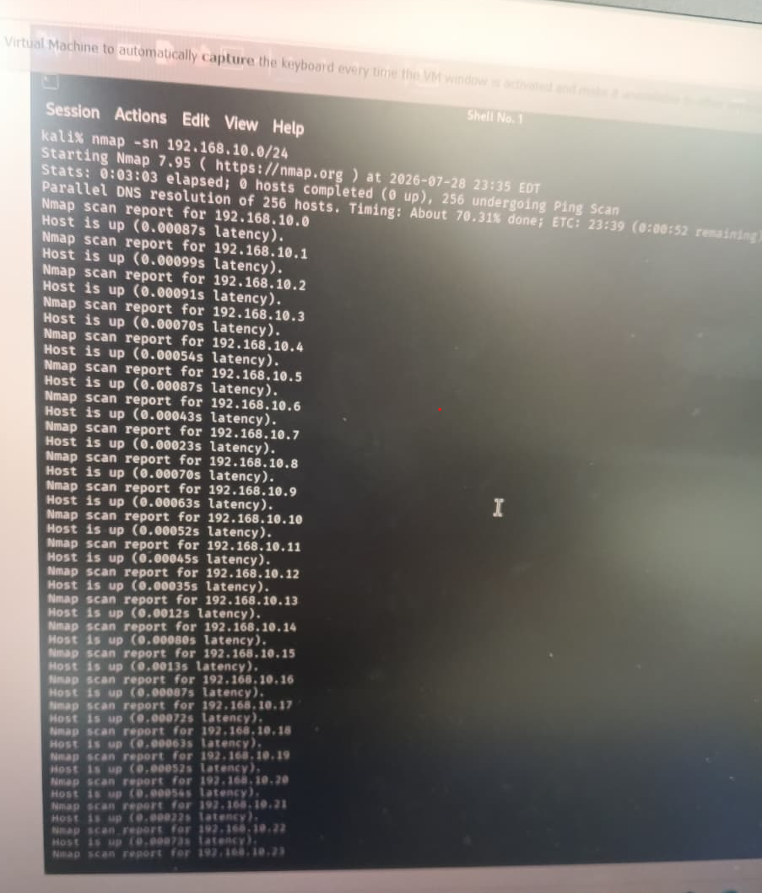

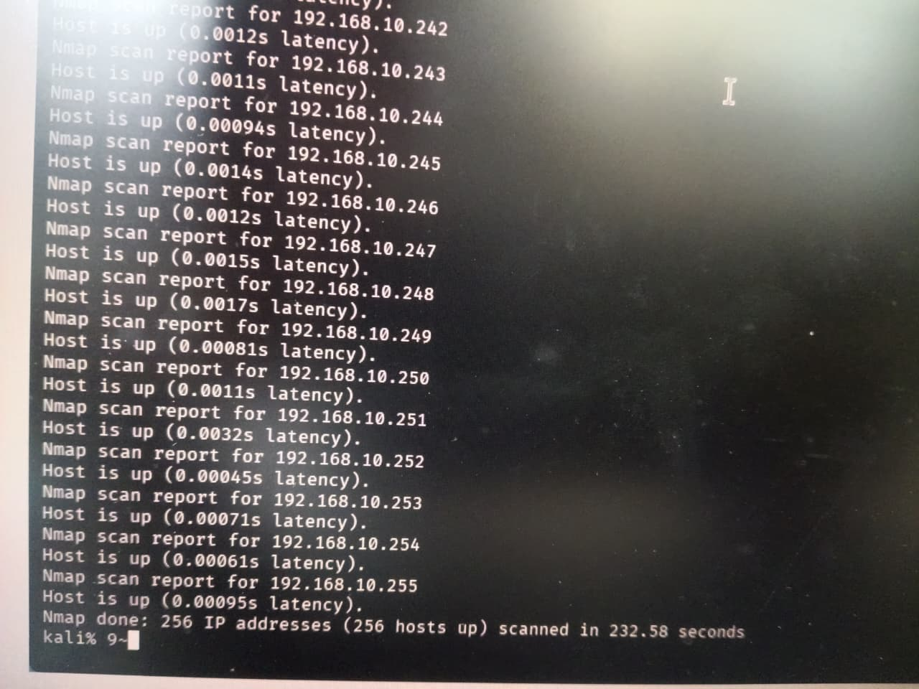

3. Brief Report
A ping sweep was performed on the 192.168.10.0/24 network using Nmap in Kali Linux. The scan found 5 active hosts. These are the devices that are currently connected to the network and responding to ping requests.

4. How Can Ping Sweep Help an Attacker?
A ping sweep helps an attacker by:
- Finding which computers or devices are online.
- Saving time by attacking only active systems.
- Helping plan the next steps, such as port scanning or vulnerability scanning.
- Learning more about the organization's network.

5. Two Security Measures
1. Block ICMP (Ping) Requests
The firewall can be configured to block ping requests. If devices do not reply to ping, it becomes harder for attackers to discover them.
2. Use IDS/IPS and Network Segmentation
- IDS/IPS (Intrusion Detection/Prevention System) can detect and alert administrators when someone performs a ping sweep.
- Network segmentation divides the network into smaller parts, making it harder for attackers to scan the entire network.

Conclusion
A ping sweep is used to find all live devices on a network. In this example, 5 active hosts were found. Attackers can use this information to identify possible targets. To reduce this risk, organizations should block unnecessary ping requests and use IDS/IPS with network segmentation to detect and limit scanning activities.

